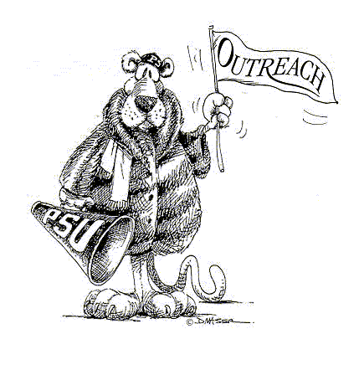
Registration Form
SAGE (Senior Adults Gaining Enrichment)
5 @ 5 Lecture Series
Please complete the form below to register for the SAGE Monthly Lecture Series and/or the 5 @ 5 Lecture Series.

Last Name First Name

Home Address

Home Phone E-mail address

_____By checking this box I agree to allow Penn State to use this email address to communicate with
me about this program.

Spring 2019 Lecture Series Fee (55+): $60
(Includes 4 lectures and lunch at each lecture) $ ______________

Individual lectures, including lunch: $20 each
(Participant must register at least 3 days prior to the program) $ __________
 | March 1st | Michael Krasja  Assistant Professor, Penn State | The Billboard Boys: The Greatest Radio Contest of all Time.  Film and Discussion
 | April 5th | Zac Jaindl  Chief Operations Officer  Jaindl Properties | The Waterfront Development: An in depth look at the development of the River District in Downtown Allentown.
 | May 3rd | Mary Erdman  Fair Districts PA | Redistricting: a non-partisan, citizen-led, statewide coalition working to create a process for redistricting that is transparent, impartial and fair.
 | June 7th | Samuel Chen  The Liddell Group | Folding the House of Cards: Media in Politics

5@5 Lecture Series $59 $ ______________
David M. Longenbach, Penn State Lehigh Valley History Faculty, presents our fall lecture series, "The American Civil War." In this five part series we'll explore the military campaigns of the Civil War from the firing on Fort Sumter to the surrender at Appomattox Court House. Join us for this exciting examination of America’s bloodiest conflict.
The series will take place Thursdays at 5 pm from May 9th to June 6th, 2019 in room 311B.

Total Amount Due $ ______________

Method of Payment:
□ A check is enclosed payable to Penn State
□ Charge my ( ) MasterCard ( ) VISA ( ) Discover ( ) American Express

________________________________________________________
Cardholder’s Signature

________________________________________________________
Cardholder’s Name (PRINT)

___________________________________ _______________
Card Number Expiration Date

Mail completed forms to:
Office of the Registrar
Penn State Lehigh Valley
2809 Saucon Valley Road
Center Valley, PA 18034-8447 Phone: 610-285-5133

