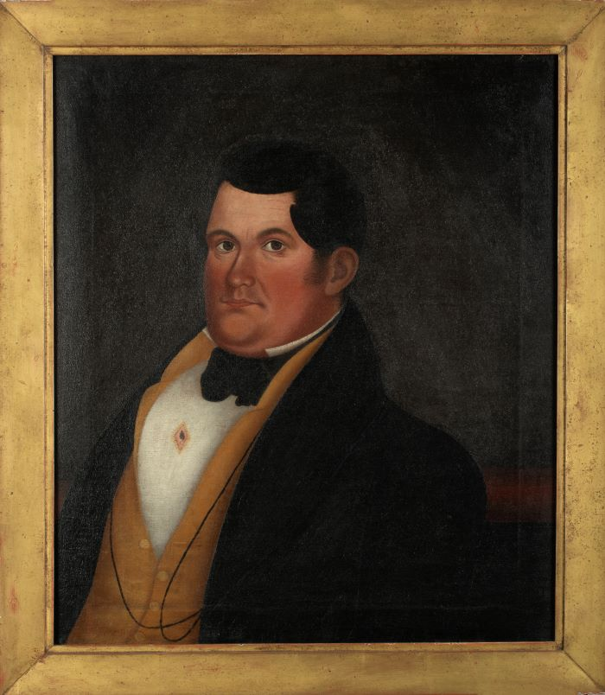

Daniel Harlow Weeks

Attributed to E.E. Finch

The painting’s frame is inscribed on the verso:

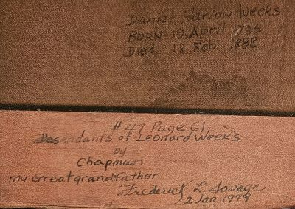

Daniel Harlow Weeks was the 6th generation descendant of Leonard Weeks of England. Leonard Weeks arrived in America in the 17th century and settled in Greenland, NH. Daniel was the second son born to Hannah (Hopkins) and Winthrop Weeks on April 19, 1796. He was one of nine children, and is listed as a farmer and cement mason. His wife, Margaret (Spear) Simpson (see image below), was born in 1796 in Jefferson, Maine. She was the daughter of Josiah Simpson (her mother’s name is unknown) and the granddaughter of William and Agnes L. Simpson. Margaret and Daniel married in Brunswick, Maine on

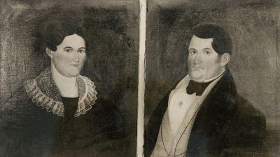

**Margaret Simpson Weeks and Daniel Harlow Weeks.**

June 2, 1818. Daniel was 22 years of age at the time. They had 13 children and 23 grandchildren.[1]

The names and life dates of their children are as follows:

1. James Potter, b. Nov. 24, 1819 (possibly 1818); d.1875*

2. Martha Jane, b. June 3, 1821; d. 1862

3. Hannah, b. Oct. 26, 1822; d. Dec. 15, 1827

4. Israel Simpson, b. Sept. 3, 1824; d.1895*

5. Margaret E., b. May 28, 1826; d.?

6. Hannah, 2nd, b. Jan. 1, 1828; d.1860

7. Daniel B., b. Aug. 28, 1829; d. Dec. 14, 1840

8. Bethania B., b. Jan. 7, 1831; d.?

9. Sarah Ann, b. Apr. 4, 1833; d.1893*

10. Mary Octavia, b. Oct. 6, 1835; d. Aug. 13, 1856

11. Asenath, b. July 1, 1836; d.?

12. Barzania B., b. Feb. 5, 1838; d.?

13. David Harlow, b. Jan 21, 1841; d. 1878 *[2]

Daniel was recorded as being “a large, robust man weighing 250 lbs.; was teacher (sic), then innkeeper in Fairfield; a farmer in Vassalboro, where he died.” [3] He was a hydraulic cement mason. Note the Masonic pin with a trowel motif proudly presented on his shirt. Daniel H. Weeks is buried along with 17 other family members, in the Weeks Family Cemetery, which is in Vassalboro, ME.

The Weeks Family Cemetery with central monument (see photograph) listing the names of eighteen family members with their respective birth and death years, and eighteen small head/foot stones scattered about the ground marking each body’s location within the cemetery. Enclosing the burial ground is decorative cast iron fencing. (see photograph on the following page)

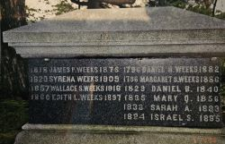

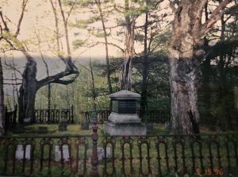

The artist E.E. Finch, to whom Daniel’s portrait is attributed, has remained a rather obscure figure. The most in depth information about Finch was presented in two articles published in the Maine Antique Digest. The first in November 1987, “E.E. Finch: A Puzzling Folk Artist” and the second, “E.E. Finch, Folk Artist- Part II,” July 1988. It was suggested that the name of E.E. Finch is Ebenezer Eames Finch, born in New Canaan, New Hampshire on April 4, 1788. He was born to Henry and Mary (Eames) Finch. [4]

What we firmly know about him is that he was an itinerant Maine folk artist working in the second quarter of the 19th century. His working dates are 1833 through 1847. His patrons, all of whom were prominent in their day, were from eastern Massachusetts, southern New Hampshire, and three central Maine counties, Lincoln, Sagadahoc, and Kennebec. All three counties border the lower Kennebec River. Vassalboro, the town Daniel resided in when his portrait was painted, is in Kennebec County.[5]

1. Rev. Jacob Chapman, Leonard Weeks of Greenland, N.H. and Descendants, 1639-1888. With Early Records of Families Connected, Including The Following Names Bailey, Bartlett, Brackett, Burley, Chapman, Chesley, Clark, Eastman, Folsom, Fowler, French, Frost, Haines, Hilton, Home, Lane, March, Mead, Moody, Moore, Philbrook, Pickering, Perkins, Rollins, Sanborn, Scammon, Thompson, Wiggin, and Wingate. (Albany, N. Y.: Joel Munsell’s Sons, Publishers. 1889), p. 61-62 & 98-99.
2. Ibid., p. 98-99. * Year of death recorded from gravestone.
3. Ibid., p. 61.
4. Marius B. Peladeau, a newspaper article, E.E. Finch, Folk Artist—Part II, Maine Antique Digest, July 1988, p.8-D.
5. Marius B. Peladeau, a newspaper article, E.E. Finch: A Puzzling Folk Artist, Maine Antique Digest, November, 1987, p. 28-D.

   Some of my research cited above has been previously published online by;

   **The New England Historic Genealogical Society**. The essay was posted on September 27, 2002,

   and is titled: ***Bringing a Portrait to Life: The Search for Daniel H. Weeks***, by Vincent DiCicco.

  